EXPT NO:4 | TRANSFORM DATA TO SUIT BI REPORTING REQUIREMENTS AND  DESIGN A DASHBOARD WITH KEY PERFORMANCE INDICATORS (KPIs ) USING TABLEAU AND POWERBI
DATE: 24.07.2026

PRE-LAB QUESTIONS (PROVIDE BRIEF ANSWERS TO THE FOLLOWING QUESTIONS)
- What is the role of data transformation in BI reporting?

Data transformation converts raw data into a clean and organized format. It improves data quality and makes the data suitable for analysis and reporting.

- What are the common data cleaning techniques in Tableau and Power BI?

- Remove duplicate records.
- Handle missing (null) values.
- Correct inconsistent data.
- Change data types.
- Filter unwanted data.
- Rename columns for better understanding.

- How do Tableau and Power BI handle data aggregation?
Both tools automatically aggregate numerical data using functions such as:
- Sum
- Average
- Count
- Minimum
- Maximum

- What are KPIs, and why are they important in a dashboard?
KPIs (Key Performance Indicators) are measurable values used to track performance. They help users monitor goals, identify trends, and make better business decisions quickly.

- What are the different types of charts available in Tableau and Power BI for visualization?
- Bar Chart
- Line Chart
- Pie Chart
- Area Chart
- Scatter Plot
- Histogram
- Tree Map
- Map
- Heat Map
- Donut Chart
- KPI Card

IN-LAB EXERCISE:
OBJECTIVE:
To transform COVID-19 data into a structured format suitable for Business Intelligence (BI) reporting and design interactive dashboards with Key Performance Indicators (KPIs) using Tableau and Power BI.

PROCEDURE:
- Data Collection:
  - Import the COVID-19 dataset from inbuilt sources like Our World in Data or CSV files containing country-level COVID statistics (e.g., new cases, deaths, vaccinations).
  - Datasets may include fields such as date, location, new_cases, total_cases, new_deaths, total_deaths, people_vaccinated, etc.
- Data Cleaning and Transformation:
  - Convert columns like date to proper date formats.
  - Handle missing or null values in new_cases, total_cases, etc.
  - Create calculated fields (e.g., daily case growth rate, case fatality rate, vaccination percentage).
- Data Aggregation:
  - Aggregate data by continent, country, or month.
  - Use measures like SUM(new_cases), AVG(positivity_rate), MAX(total_deaths).
- Designing KPIs:
  - Identify KPIs such as:
    - Total Confirmed Cases
    - Total Deaths
    - Case Fatality Rate
    - Vaccination Coverage (%)
    - Daily Case Growth Rate
  - Use DAX (Power BI) or Calculated Fields (Tableau) to compute and visualize these KPIs.
- Dashboard Development:
  - Build visualizations such as:
    - Line charts for daily new cases and deaths
    - Bar charts for country-wise vaccination progress

    - Maps to show regional case distribution
    - KPI cards for high-level insights
  - Use filters (e.g., by continent, country) and slicers (e.g., by date range) for interactivity.
- Publishing and Sharing:
  - Publish the dashboard using Tableau Public/Server or Power BI Service.
  - Share the dashboards with stakeholders through public or organizational portals.
Experiment Dataset:
COVID-19 Global Dataset Fields Used:
  - Date – Date of the report
  - Location – Country or region
  - New Cases – Daily reported cases
  - New Deaths – Daily reported deaths
  - People Vaccinated – Cumulative vaccinated count
  - Total Cases – Cumulative confirmed cases
  - Total Deaths – Cumulative deaths
  - Population – Total population of the country

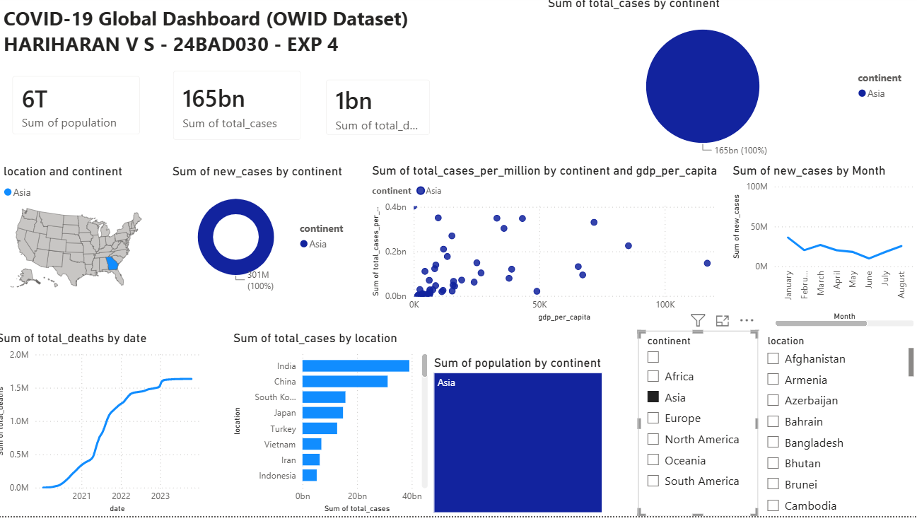

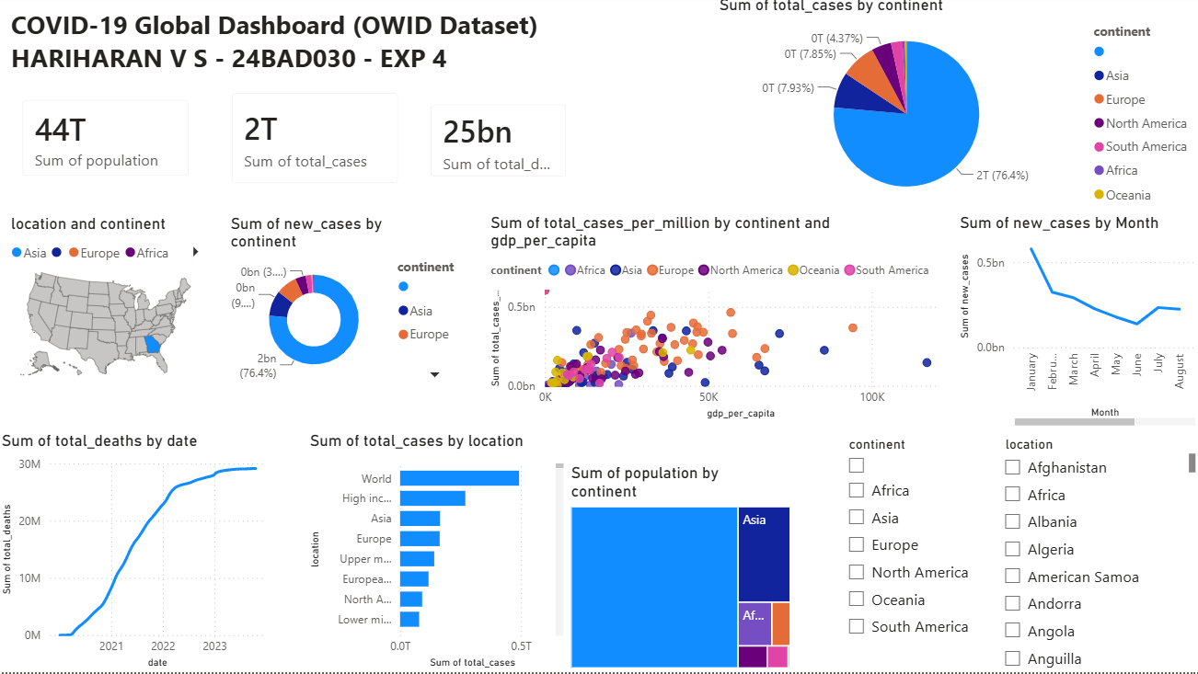

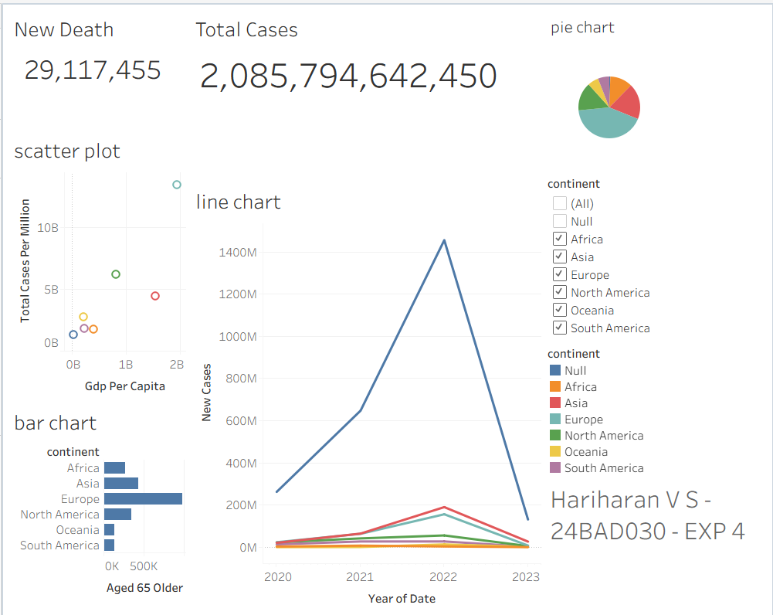

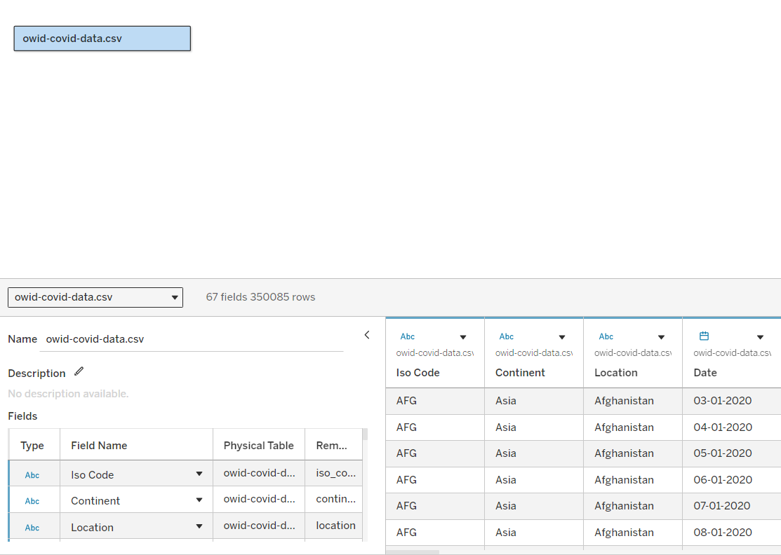

POST-LAB QUESTIONS (PROVIDE BRIEF ANSWERS TO THE FOLLOWING QUESTIONS)
- How did data transformation improve the quality of insights in your COVID-19 dashboard?

Data transformation improved the accuracy and consistency of the analysis by cleaning missing values, converting data types, and creating calculated fields such as case fatality rate and vaccination percentage. It made the data easier to analyze and visualize, resulting in more meaningful insights.

- What challenges did you encounter during the data cleaning process, and how did you resolve them?

The main challenges were handling missing values, inconsistent date formats, and null entries in vaccination and case data. These issues were resolved by replacing or removing missing values, converting dates into a standard format, and validating the data before analysis.

- Which KPI provided the most valuable insight, and why?

The Vaccination Coverage (%) KPI provided the most valuable insight because it showed the progress of vaccination campaigns across different countries. It helped compare immunization levels and understand their impact on controlling the spread of COVID-19.

- How does interactivity in dashboards improve user experience?

Interactive dashboards allow users to filter data by country, continent, or date range, drill down into specific details, and explore trends dynamically. This makes data analysis more flexible, engaging, and useful for decision-making.

- What steps would you take to further enhance the dashboard’s effectiveness?
The dashboard can be enhanced by adding predictive trend analysis, more KPIs such as recovery rate and active cases, real-time data updates, customizable filters, and improved visualizations with tooltips and drill-through reports for deeper analysis.

RESULT:

The COVID-19 dataset was successfully cleaned, aggregated, and transformed for visual analysis using Tableau and Power BI. Missing values, data type mismatches, and inconsistencies were addressed. KPIs such as vaccination rate and daily case growth offered valuable insights into the pandemic trends across countries and timeframes. The resulting interactive dashboards allowed for effective public health monitoring and communication.

ASSESSMENT

Description | Max Marks | Marks Awarded
Pre Lab Exercise | 5
In Lab Exercise | 10
Post Lab Exercise | 5
Viva | 10
Total | 30
Faculty Signature

